Supplementary Materials

Supplementary Figure 1. Predicted trends of time-in-range stratified by treatment switch.

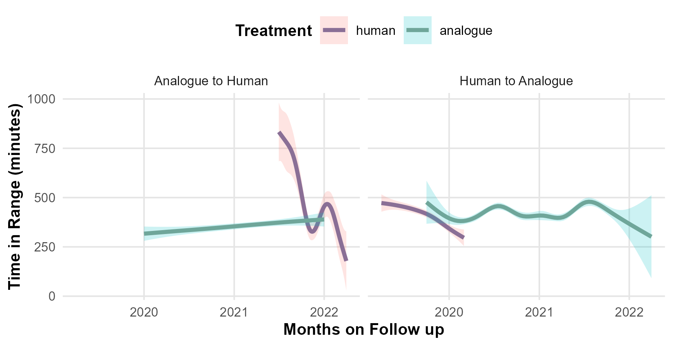

Supplementary Table 1. Different versions of datasets.
 | Date-Time dataset* | Date Only dataset* | Valid dates dataset
Total patients included | 45 | 45 | 45
Total CGM Days | 13 763 | 13 763 | 10 967
Total days on human | 4 310 (36%) | 4 310 (36%) | 3 301 (30%)
Total days on analogue | 9 453 (64%) | 9 453 (64%) | 7 666 (70%)
Rows in panel dataset | 1 101 246 | 13 763 | 10 967
*Date Only dataset is a concise version of Date-Time dataset. It includes only dates rather than date and time, so it has the same information and the same number of patients and glucose readings.

Supplementary Table 2. Total glucose readings per treatment.
 | CGM Days | Glucose readings | Total hours captured | Mean hours per day
Human insulin | 3301 | 295561 | 75169 | 22.8 (± 1.8)
Analogue insulin | 7666 | 687440 | 175312 | 22.9 (± 1.6)

Supplementary Table 3. Sensitivity analysis.
 | Full reported model  (All patients and switching episodes)  N= 45 patients  (10967 days) | Alternative Model 1  Adjusted for switch category  (All switching episodes)  N= 45 patients  (10967 days) | Alternative Model 2  Adjusted for switch category  (One switch episode)  N= 45 patients  (10119 days) | Alternative Model 3  Adjusted for calendar month  (One switch episode)  N= 45 patients  (10119 days)
 | Mixed model with patient random intercept | Mixed model with patient random intercept | Mixed model with patient random intercept | Fixed effect model
TIR (minutes)  Effect estimate  [95%CI] | 26  [15 – 37]  (p-value <0.001) | 26  [15 – 37]  (p-value <0.001) | 25  [13 – 37]  (p-value <0.001) | 102  [44 – 159]  (p-value <0.001)
TBR (minutes)  Effect estimate  [95%CI] | -11  [(-16) – (-5)]  (p-value <0.001) | -11  [(-16) – (-5)]  (p-value <0.001) | -13  [(-19) – (-6)]  (p-value <0.001) | 17  [(-11) – 44]  (p-value: 0.2)
24-hr Mean Glucose (mg/dl)  Effect estimate  [95%CI] | -6  [(-8) – (-3)]  (p-value <0.001) | -6  [(-9) – (-3)]  (p-value <0.001) | -4  [(-7) – (-1)]  (p-value <0.01) | -34  [(-54) – (-15)]  (p-value <0.01)
Sensitivity analysis for the association between analogue insulin and the times within and below target range and mean daily glucose.
TBR: Time below target range; TIR: Time in target range.

